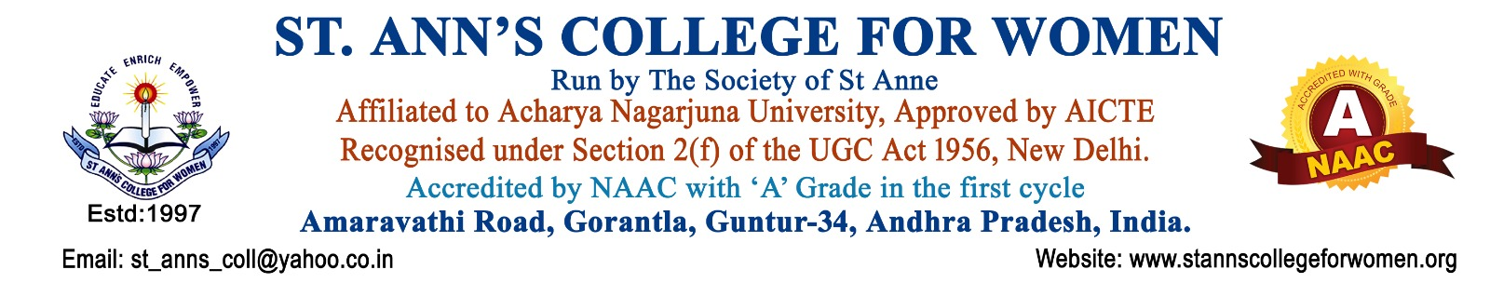

Tours & Travels Committee
Guidelines, Procedures & Activities
1. Introduction
The Tours & Travels Committee of St. Ann’s College for Women, Gorantla, Guntur is established to organize educational tours, industrial visits, field trips, study tours, and experiential learning programs for students.
The committee aims to provide practical exposure, educational experiences, industry interaction, cultural awareness, and holistic learning beyond the classroom. The committee functions in alignment with NAAC guidelines to promote experiential learning, student engagement, and skill development.

2. Objectives
The objectives of the Tours & Travels Committee are to:
- Plan and organize educational tours and field visits.
- Provide practical exposure and experiential learning opportunities.
- Coordinate with industries, institutions, travel agencies, and organizations.
- Arrange transportation, accommodation, and food facilities.
- Ensure safety, discipline, and well-being of students during tours.
- Promote teamwork, leadership, and social interaction among students.
- Enhance academic knowledge through field exposure.
- Maintain records and reports of tours and visits.

3. Constitution of the Committee
The Tours & Travels Committee shall consist of:
- Principal – Chairperson
- Tours Committee Coordinator / Convener
- Faculty Members
- Department Representatives
- IQAC Representative
- Student Representatives

4. Roles and Responsibilities
The committee shall:
- Plan educational tours, industrial visits, and field trips.
- Coordinate with industries, institutions, and travel agencies.
- Prepare tour schedules, permissions, and instructions.
- Arrange transportation, accommodation, and food facilities.
- Collect consent forms and required student documents.
- Ensure student safety, discipline, and attendance during tours.
- Provide faculty supervision and coordination during travel.
- Manage tour budget and expenses.
- Maintain records, reports, and feedback of all tours.

5. Procedures
Step 1: Planning of Tour
- Departments shall identify suitable places for educational visits and submit proposals for approval.
Step 2: Approval and Permissions
- Permission shall be obtained from the Principal and concerned authorities.
- Consent letters from parents/guardians shall be collected.
Step 3: Travel Arrangements
The committee shall arrange:
- Transportation
- Accommodation
- Food facilities
- Travel schedules
- Emergency contact details
Step 4: Student Orientation
- Students shall be informed about:
  - Tour schedule
  - Safety rules
  - Discipline guidelines
  - Reporting timings
  - Required documents
Step 5: Conduct of Tour
- Faculty members shall accompany students and supervise activities during the trip.
Step 6: Feedback and Reporting
- Feedback shall be collected from students and faculty.
- Tour reports and photographs shall be documented.

6. Activities of the Committee
The committee may organize:
- Educational Tours
- Industrial Visits
- Field Trips
- Study Tours
- Historical and Cultural Visits
- Nature and Environmental Visits
- Research and Project Visits
- Institutional Visits

7. Safety and Discipline Guidelines
The committee shall ensure:
- Student safety during travel and stay.
- Proper attendance and supervision.
- Discipline and responsible behavior.
- Availability of emergency contacts and first aid support.
- Compliance with institutional rules and travel guidelines.

8. Documentation and Records
The committee shall maintain:
- Tour Proposals and Approvals
- Student Consent Forms
- Attendance Records
- Travel and Expense Details
- Tour Reports
- Photographs and Feedback Forms
- Meeting Minutes and Annual Reports

9. NAAC Compliance
The Tours & Travels Committee functions in alignment with:
- NAAC Experiential Learning Practices
- Student-Centric Learning Approaches
- Holistic Education and Skill Development Initiatives
The committee contributes to:
- Practical Learning
- Industry Exposure
- Student Development
- Teamwork and Leadership
- Institutional Quality Enhancement

10. Expected Outcomes
The activities of the committee are expected to:
- Enhance practical and experiential learning.
- Improve student exposure to industries and institutions.
- Promote teamwork, confidence, and leadership.
- Strengthen academic understanding through field experience.
- Encourage discipline and responsible behavior.

11. Conclusion
St. Ann’s College for Women, Gorantla, Guntur is committed to providing experiential learning opportunities through educational tours and field visits. The Tours & Travels Committee plays an important role in enhancing practical knowledge, student exposure, and holistic development in alignment with NAAC quality standards.

